

PROJECT REVIEW – 3

J – COMPONENT

COURSE : ADVANCED JAVA PROGRAMMING

COURSE CODE : SWE2013

**TOPIC – ONLINE CAR RENTAL SYSTEM**

NAME – DIVAKAR.R

REG NO – 16MIS0069

SLOT – D1+TD1

UNDER FACULTY – PROF.ANITHA.A

**1)ABSTRACT:**

“This project online car rental system” allows a person to book/reserve a vehicle with/without payment on one end while the company staff or server handles the transactions, on the other via the Internet. Once the user is authenticated he is authorized to view the cars and booking can be done. Online Car Rental Systems are used mostly in developed countries such as England and Australia where electronic commerce has been fully accepted in the society. Famous companies such as Europcar from United Kingdom, has gained popularity since the business used the technologies available to expand and provide more facilities to their customers. The basic functions of an online car rental system are to keep tracks of vehicles, staff, customers and booking. It provides useful information to the staff such as giving daily reports of vehicles to be delivered/picked up and acts as a vehicle management system by monitoring the use and price of the vehicles. The most advanced travel agents offering cab rental and car hire in India, making full use of information technology to improve the level of our efficiency. However, this is only one aspect of services. And this project continually strive to offer the best of services - both in terms of man and machine, to our clients

**2)INTRODUCTION:**

Online car rental system makes the booking process easier by avoiding the confusion and delay in the assignment works . Thus converting to online mode helps the user to easily look and book the car and can rent it based on their needs. When it comes to cab rental services, The most advanced travel agents offering cab rental and car hire in India, making full use of information technology to improve the level of our efficiency. However, this is only one aspect of services. And this project continually strive to offer the best of services - both in terms of man and machine, to our clients Moreover, this project has  a fleet of cars ranging from luxury to budget cabs. While, it offers online cab hire service for corporate houses. And this project claim to offer the best of rates, Team of professionals in the travel business enables this system to design trips that suits to all budgets and preferences of the travellers. In addition, workforce including drivers and administrative staff are well trained to discharge their duties with a lot of efficiency. Lets discuss in detail about the project.

**3)Hardware Requirement:**

Minimum hardware requirement to download Java on your Windows operating system as follows:

* Minimum Windows 95 software
* IBM-compatible 486 system
* Hard Drive and Minimum of 8 MB memory
* Mouse, keyboard and sound card, if required

**Software requirement :**

Nowadays, Java is supported by almost every operating systems. whether it is a Windows, Macintosh and Unix all supports the Java application development. So you can download any of the operating system on your personal computer. Here are the minimum requirement.

* Operating System
* Java SDK or JRE 1.6 or higher
* Java Servlet Container (Free Servlet Container available)
* Supported Database and library that supports the database connection with Java.
* Wamp server
* Netbeans ide
* Glassfish server

**4) ARCHITECTURE:**

**0-DFD:**

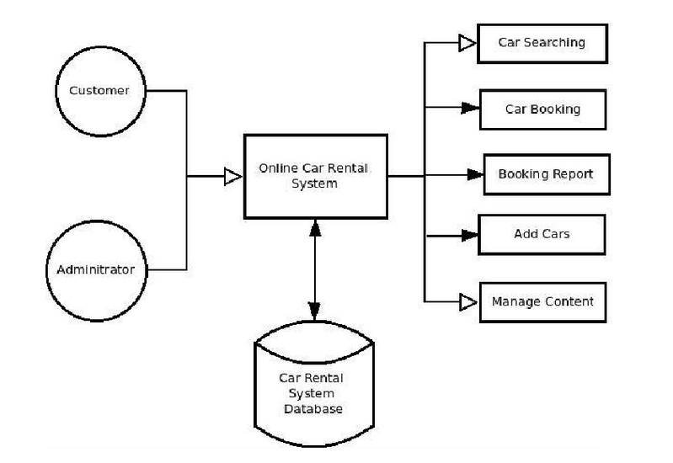

**1-DFD:**

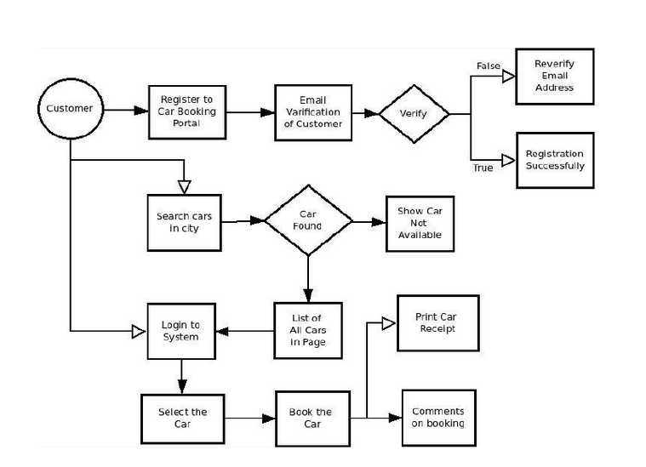

**4. Modules of the Projects:**

➢  Admin module

➢   Login module

➢  Car rental  module

➢  Hotel module

➢  Contact desk module

**Login module:**

* In login module, initially authentication was provided.
* Only if the authentication is accepted further we can login and access other contents.
* If not again it will be redirected to main page.

**Admin module;**

* Admin has the rights to lookover the process and perhaps the acception and rejection status also has the authorization control to admin.

**Car rental module:**

* Car rental module, the user will be seeing the list of cars with prices of the concerned cars and are made available to book the cars then and there to avoid last mine hassles.
* Also we can pay later.

**Hotel module:**

* This is a added module which acts as a useful source to book rooms in the new places.
* The user’s burden is taken into our hands and altogether combined in the single platform thus the online car rental system namely R&D cabs.

**Contact desk module:**

This is a an end user’s help desk to clear their queries and solve the issues then and there.

**PROBLEM & SOLUTION:**

**Existing System:**

R&D cabs is an innovative thought to simplify the Transportation problems of Employees of an organization. In the present System, Organization do maintain a person for the allocating and proper functioning of transportation .The Person appointed needs to look after the assigning and movement of cabs. Authorised person maintains the transportation details in papers, which is a tedious task if any updation or changes need to be done.

➢  Details are stored in Papers.

➢  Maintenance is a huge problem.

➢  Updation, changes in details is a tedious task.

➢  Performance is not achieved up to the requirements.

**Proposed System**  :

                                    In the Previous System, Details are Stored Manually in papers to share the details between employees was a Financial drawback. Updations in the details is a tedious task.

But a new system was proposed to overcome the above drawbacks.

Functionalities and advantages of proposed system are:

➢  Data is Centralized which has overcome the Sharing problem in previous system.

➢  As data is Maintained electronically, it’s easy for a person to update the details, which has overcome the tedious updation in previous system.

➢  Maintenance is easy and performance is good.

➢  Mainly the system has automated the Transportation Process.

5.EXPERIMENTAL ANALYSIS:

5.1 CODING

<!DOCTYPE html>

<html>

<title>W3.CSS Template</title>

<meta charset="UTF-8">

<meta name="viewport" content="width=device-width, initial-scale=1">

<link rel="stylesheet" href="https://www.w3schools.com/w3css/4/w3.css">

<link rel="stylesheet" href="https://fonts.googleapis.com/css?family=Raleway">

<link rel="stylesheet" href="https://cdnjs.cloudflare.com/ajax/libs/font-awesome/4.7.0/css/font-awesome.min.css">

<style>

body,h1,h2,h3,h4,h5,h6 {font-family: "Raleway", Arial, Helvetica, sans-serif}

.myLink {display: none}

</style>

<body class="w3-light-grey">

<!-- Navbar (sit on top) -->

<div class="w3-top">

<div class="w3-bar w3-white w3-wide w3-padding w3-card">

<a href="#home" class="w3-bar-item w3-button"><b><i class="fa fa-car w3-margin-right"></i></b>Looking</b> for car rentals with exciting offers?</a>

<!-- Float links to the right. Hide them on small screens -->

<div class="w3-right w3-hide-small">

<a href="#offer" class="w3-bar-item w3-button">Offers% </a>

<a href="#bookcar" class="w3-bar-item w3-button">Rent cars</a>

<a href="#bookhotel" class="w3-bar-item w3-button">Hotels</a>

<a href="contact.jsp" class="w3-bar-item w3-button">Contact us</a>

<a href="book.jsp" class="w3-bar-item w3-button">Log out</a>

</div>

</div>

</div>

<!-- Header -->

<header class="w3-display-container w3-content w3-wide" style="max-width:1500px;" id="home">

<img class="w3-image" src="1.jpg" alt="Architecture" width="1500" height="800">

<div class="w3-display-middle w3-margin-top w3-center">

<h1 class="w3-xxlarge w3-text-white"><span class="w3-padding w3-black w3-opacity-min"><b>R&D</b></span>CABS <span class="w3-hide-small w3-text-light-grey"></span></h1>

<a href="#About" class="w3-bar w3-white w3-card">India's largest car rental service with added benefits

</header>

<!-- Page content -->

<div class="w3-content" style="max-width:1100px;">

<!-- Good offers -->

<div class="w3-container w3-margin-top" id="offer">

<h3>Good Offers Right Now</h3>

<h6>Up to <strong>50%</strong> discount on booking</h6>

</div>

<div class="w3-row-padding w3-text-white w3-large">

<div class="w3-half w3-margin-bottom">

<div class="w3-display-container">

<img src="0.jpg" alt="Honda xt" style="width:100%">

<span class="w3-display-bottomleft w3-padding">Honda xt</span>

</div>

</div>

<div class="w3-half">

<div class="w3-row-padding" style="margin:0 -16px">

<div class="w3-half w3-margin-bottom">

<div class="w3-display-container">

<img src="3.jpg" alt="ferrari" style="width:100%">

<span class="w3-display-bottomleft w3-padding">ferrari</span>

</div>

</div>

<div class="w3-half w3-margin-bottom">

<div class="w3-display-container">

<img src="3.jpg" alt="Rolls royce" style="width:100%">

<span class="w3-display-bottomleft w3-padding">Rolls royce</span>

</div>

</div>

</div>

<div class="w3-row-padding" style="margin:0 -16px">

<div class="w3-half w3-margin-bottom">

<div class="w3-display-container">

<img src="t1.jpg" alt="Limo" style="width:100%">

<span class="w3-display-bottomleft w3-padding">Limo</span>

</div>

</div>

<div class="w3-half w3-margin-bottom">

<div class="w3-display-container">

<img src="t1.jpg" alt="Limo" style="width:100%">

<span class="w3-display-bottomleft w3-padding">Limo</span>

</div>

</div>

</div>

</div>

</div>

<!-- Book cars -->

<div class="w3-container" id="bookcar">

<h3>We provide our best services only for customer satisfaction</h3>

<p>Rent the car with us and start exploring now!.</p>

</div>

<div class="w3-row-padding">

<div class="w3-half w3-margin-bottom">

<img src="123.jpg" alt="Norway" style="width:100%">

<div class="w3-container w3-white">

<h3>Limo</h3>

<p class="w3-opacity">Roundtrip from $79</p>

<p>A/C & Free wifi</p>

<a href ="bookcar.jsp"</a> <button class="w3-button w3-margin-bottom">Book now</button>

</div>

</div>

<div class="w3-half w3-margin-bottom">

<img src="index.jpg" alt="Austria" style="width:100%">

<div class="w3-container w3-white">

<h3>Honda i20</h3>

<p class="w3-opacity">One-way from $39</p>

<p>A/C & Free wifi</p>

<a href ="bookcar.jsp"</a> <button class="w3-button w3-margin-bottom">Book now</button>

</div>

</div>

<div class="w3-half w3-margin-bottom">

<img src="123.jpg" alt="Austria" style="width:100%">

<div class="w3-container w3-white">

<h3>Honda i20</h3>

<p class="w3-opacity">One-way from $59</p>

<p>A/C & Free wifi</p>

<a href ="bookcar.jsp"</a> <button class="w3-button w3-margin-bottom">Book now</button>

</div>

</div>

<div class="w3-half w3-margin-bottom">

<img src="t1.jpg" alt="Austria" style="width:100%">

<div class="w3-container w3-white">

<h3>Honda i20</h3>

<p class="w3-opacity">One-way from $29</p>

<p>A/C & Free wifi</p>

<a href ="bookcar.jsp"</a> <button class="w3-button w3-margin-bottom">Book now</button>

</div>

</div>

<div class="w3-half w3-margin-bottom">

<img src="t2.jpg" alt="Austria" style="width:100%">

<div class="w3-container w3-white">

<h3>Honda i20</h3>

<p class="w3-opacity">One-way from $39</p>

<p>A/C & Free wifi</p>

<a href ="bookcar.jsp"</a> <button class="w3-button w3-margin-bottom">Book now</button>

</div>

</div>

<div class="w3-half w3-margin-bottom">

<img src="t3.jpg" alt="Austria" style="width:100%">

<div class="w3-container w3-white">

<h3>Honda i20</h3>

<p class="w3-opacity">One-way from $39</p>

<p>A/C & Free wifi</p>

<a href ="bookcar.jsp"</a> <button class="w3-button w3-margin-bottom">Book now</button>

</div>

</div>

<div class="w3-half w3-margin-bottom">

<img src="t5.jpg" alt="Austria" style="width:100%">

<div class="w3-container w3-white">

<h3>Honda i20</h3>

<p class="w3-opacity">One-way from $55</p>

<p>A/C & Free wifi</p>

<a href ="bookcar.jsp"</a> <button class="w3-button w3-margin-bottom">Book now</button>

</div>

</div>

<div class="w3-half w3-margin-bottom">

<img src="t5.jpg" alt="Austria" style="width:100%">

<div class="w3-container w3-white">

<h3>Honda i20</h3>

<p class="w3-opacity">One-way from $65</p>

<p>A/C & Free wifi</p>

<a href ="bookcar.jsp"</a> <button class="w3-button w3-margin-bottom">Book now</button>

</div>

</div>

<div class="w3-half w3-margin-bottom">

<img src="t1.jpg" alt="Austria" style="width:100%">

<div class="w3-container w3-white">

<h3>Honda i20</h3>

<p class="w3-opacity">One-way from $85</p>

<p>A/C & Free wifi</p>

<a href ="bookcar.jsp"</a> <button class="w3-button w3-margin-bottom">Book now</button>

</div>

</div>

<div class="w3-half w3-margin-bottom">

<img src="t1.jpg" alt="Austria" style="width:100%">

<div class="w3-container w3-white">

<h3>Honda i20</h3>

<p class="w3-opacity">One-way from $78</p>

<p>A/C & Free wifi</p>

<a href ="bookcar.jsp"</a> <button class="w3-button w3-margin-bottom">Book now</button>

</div>

</div>

</div>

<!---Hotel---->

<div class="w3-container" id="bookhotel">

<h3>We provide our best services only for customer satisfaction</h3>

<p>Rent the car with us and start exploring now!.</p>

</div>

<div class="w3-row-padding">

<div class="w3-half w3-margin-bottom">

<img src="x6.jpg" alt="Norway" style="width:100%">

<div class="w3-container w3-white">

<h3>Taj group of hotels</h3>

<p class="w3-opacity">Starting from $79</p>

<p>A/C & Free wifi</p>

<a href ="hotelbook.jsp"</a> <button class="w3-button w3-margin-bottom">Book now</button>

</div>

</div>

<div class="w3-half w3-margin-bottom">

<img src="x7.jpg" alt="Austria" style="width:100%">

<div class="w3-container w3-white">

<h3>Lt residency</h3>

<p class="w3-opacity">Starting from $39</p>

<p>A/C & Free wifi</p>

<a href ="hotelbook.jsp"</a> <button class="w3-button w3-margin-bottom">Book now</button>

</div>

</div>

<div class="w3-half w3-margin-bottom">

<img src="x7.jpg" alt="Austria" style="width:100%">

<div class="w3-container w3-white">

<h3>Hotel Zyan</h3>

<p class="w3-opacity">Starting from $59</p>

<p>A/C & Free wifi</p>

<a href ="hotelbook.jsp"</a> <button class="w3-button w3-margin-bottom">Book now</button>

</div>

</div>

<div class="w3-half w3-margin-bottom">

<img src="x2.jpg" alt="Austria" style="width:100%">

<div class="w3-container w3-white">

<h3>Hyatt esidency</h3>

<p class="w3-opacity">Starting from $29</p>

<p>A/C & Free wifi</p>

<a href ="hotelbook.jsp"</a> <button class="w3-button w3-margin-bottom">Book now</button>

</div>

</div>

<div class="w3-half w3-margin-bottom">

<img src="x5.jpg" alt="Austria" style="width:100%">

<div class="w3-container w3-white">

<h3>Park residency</h3>

<p class="w3-opacity">Starting from $39</p>

<p>A/C & Free wifi</p>

<a href ="hotelbook.jsp"</a> <button class="w3-button w3-margin-bottom">Book now</button>

</div>

</div>

<div class="w3-half w3-margin-bottom">

<img src="x4.jpg" alt="Austria" style="width:100%">

<div class="w3-container w3-white">

<h3>Hotel shivalaya</h3>

<p class="w3-opacity">Starting from $39</p>

<p>A/C & Free wifi</p>

<a href ="hotelbook.jsp"</a> <button class="w3-button w3-margin-bottom">Book now</button>

</div>

</div>

<div class="w3-half w3-margin-bottom">

<img src="x5.jpg" alt="Austria" style="width:100%">

<div class="w3-container w3-white">

<h3>Valley resort</h3>

<p class="w3-opacity">Starting from $55</p>

<p>A/C & Free wifi</p>

<a href ="hotelbook.jsp"</a> <button class="w3-button w3-margin-bottom">Book now</button>

</div>

</div>

<div class="w3-half w3-margin-bottom">

<img src="x6.jpg" alt="Austria" style="width:100%">

<div class="w3-container w3-white">

<h3>Hotel amazon</h3>

<p class="w3-opacity">Starting from $65</p>

<p>A/C & Free wifi</p>

<a href ="hotelbook.jsp"</a> <button class="w3-button w3-margin-bottom">Book now</button>

</div>

</div>

<div class="w3-half w3-margin-bottom">

<img src="x7.jpg" alt="Austria" style="width:100%">

<div class="w3-container w3-white">

<h3>Hotel palm tree</h3>

<p class="w3-opacity">Starting from $85</p>

<p>A/C & Free wifi</p>

<a href ="hotelbook.jsp"</a> <button class="w3-button w3-margin-bottom">Book now</button>

</div>

</div>

<div class="w3-half w3-margin-bottom">

<img src="x1.jpg" alt="Austria" style="width:100%">

<div class="w3-container w3-white">

<h3>Hotel park avenue</h3>

<p class="w3-opacity">Starting from $78</p>

<p>A/C & Free wifi</p>

<a href ="hotelbook.jsp"</a> <button class="w3-button w3-margin-bottom">Book now</button>

</div>

</div>

</div>

<!-- Newsletter -->

<div class="w3-container">

<div class="w3-panel w3-padding-16 w3-black w3-opacity w3-card w3-hover-opacity-off">

<h2>Get the best offers first!</h2>

<p>Join our newsletter.</p>

<label>E-mail</label>

<input class="w3-input w3-border" type="text" placeholder="Your Email address">

<button type="button" class="w3-button w3-red w3-margin-top">Subscribe</button>

</div>

</div>

<!-- Contact -->

<div class="w3-container">

<h2>Contact</h2>

<p>Let us book your next trip!</p>

<i class="fa fa-map-marker" style="width:30px"></i> Chennai,India head office<br>

<i class="fa fa-phone" style="width:30px"></i> Phone: +00 151515<br>

<i class="fa fa-envelope" style="width:30px"> </i> Email: divakar685@gmail.com<br>

<form action="/action_page.php" target="_blank">

<p><input class="w3-input w3-padding-16 w3-border" type="text" placeholder="Name" required name="Name"></p>

<p><input class="w3-input w3-padding-16 w3-border" type="text" placeholder="Email" required name="Email"></p>

<p><input class="w3-input w3-padding-16 w3-border" type="text" placeholder="Message" required name="Message"></p>

<p><button class="w3-button w3-black w3-padding-large" type="submit">SEND MESSAGE</button></p>

</form>

</div>

<!-- End page content -->

</div>

<!-- Footer -->

<footer class="w3-container w3-center w3-opacity w3-margin-bottom">

<h5>Find Us On</h5>

<div class="w3-xlarge w3-padding-16">

<i class="fa fa-facebook-official w3-hover-opacity"></i>

<i class="fa fa-instagram w3-hover-opacity"></i>

<i class="fa fa-snapchat w3-hover-opacity"></i>

<i class="fa fa-pinterest-p w3-hover-opacity"></i>

<i class="fa fa-twitter w3-hover-opacity"></i>

<i class="fa fa-linkedin w3-hover-opacity"></i>

</div>

<p>Powered by <a href="https://www.w3schools.com/w3css/default.asp" target="_blank" class="w3-hover-text-green">w3.css</a></p>

</footer>

<script>

// Tabs

function openLink(evt, linkName) {

var i, x, tablinks;

x = document.getElementsByClassName("myLink");

for (i = 0; i < x.length; i++) {

x[i].style.display = "none";

}

tablinks = document.getElementsByClassName("tablink");

for (i = 0; i < x.length; i++) {

tablinks[i].className = tablinks[i].className.replace(" w3-red", "");

}

document.getElementById(linkName).style.display = "block";

evt.currentTarget.className += " w3-red";

}

// Click on the first tablink on load

document.getElementsByClassName("tablink")[0].click();

</script>

</body>

</html>

5.2 SNAPSHOTS:

login page

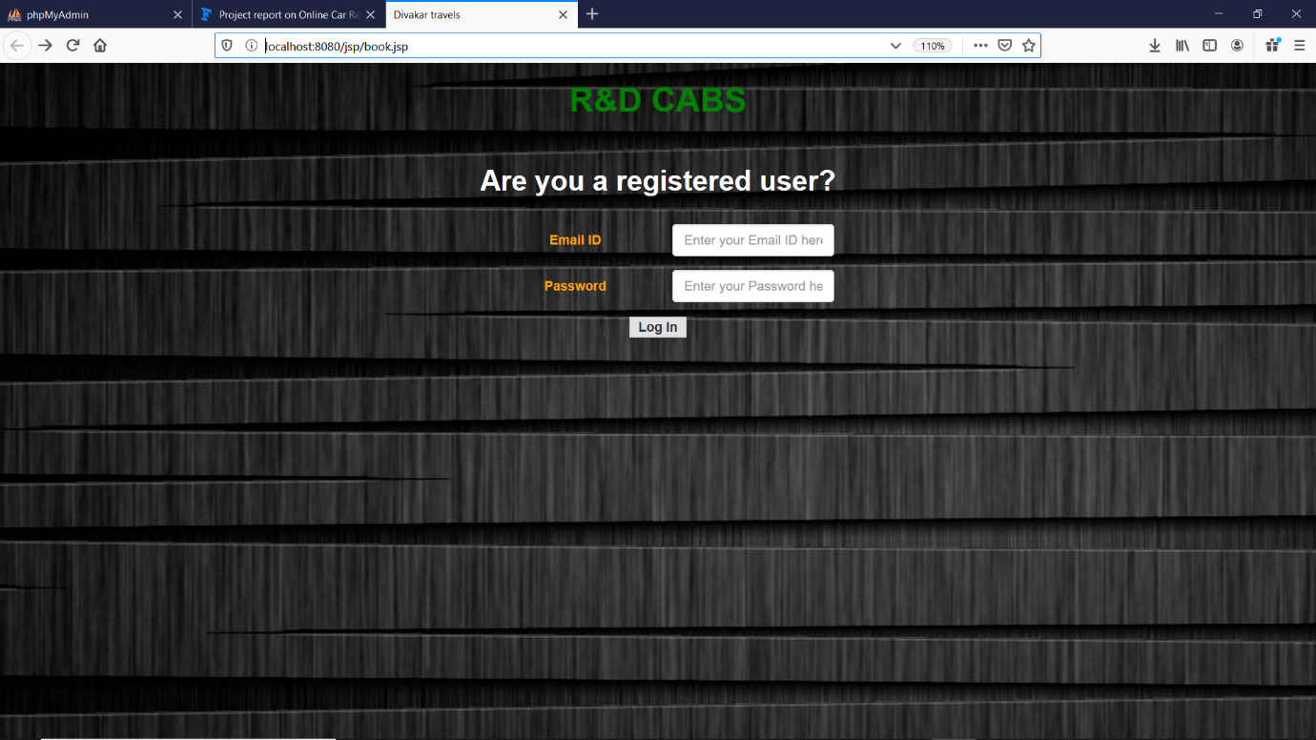

Home page

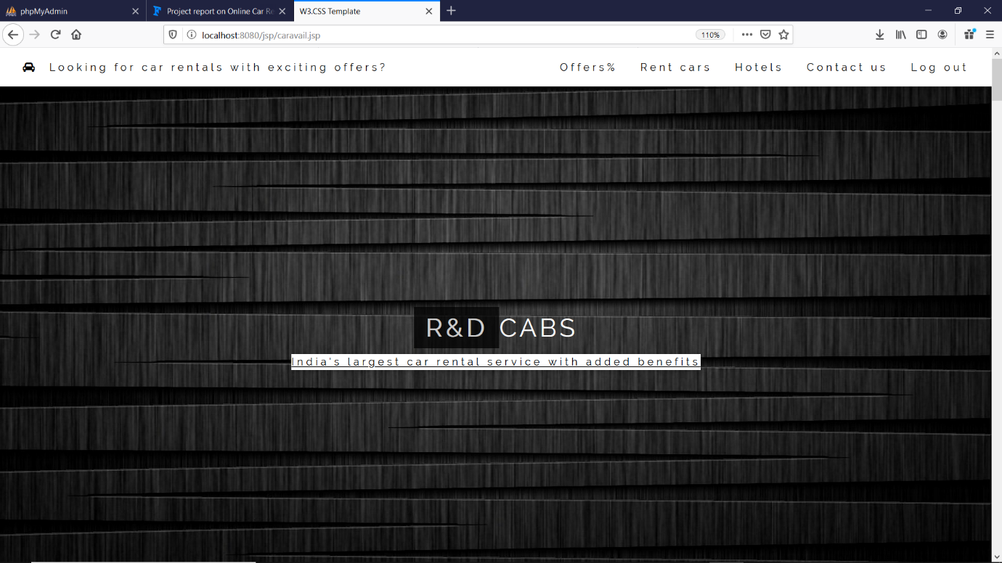

Offers page

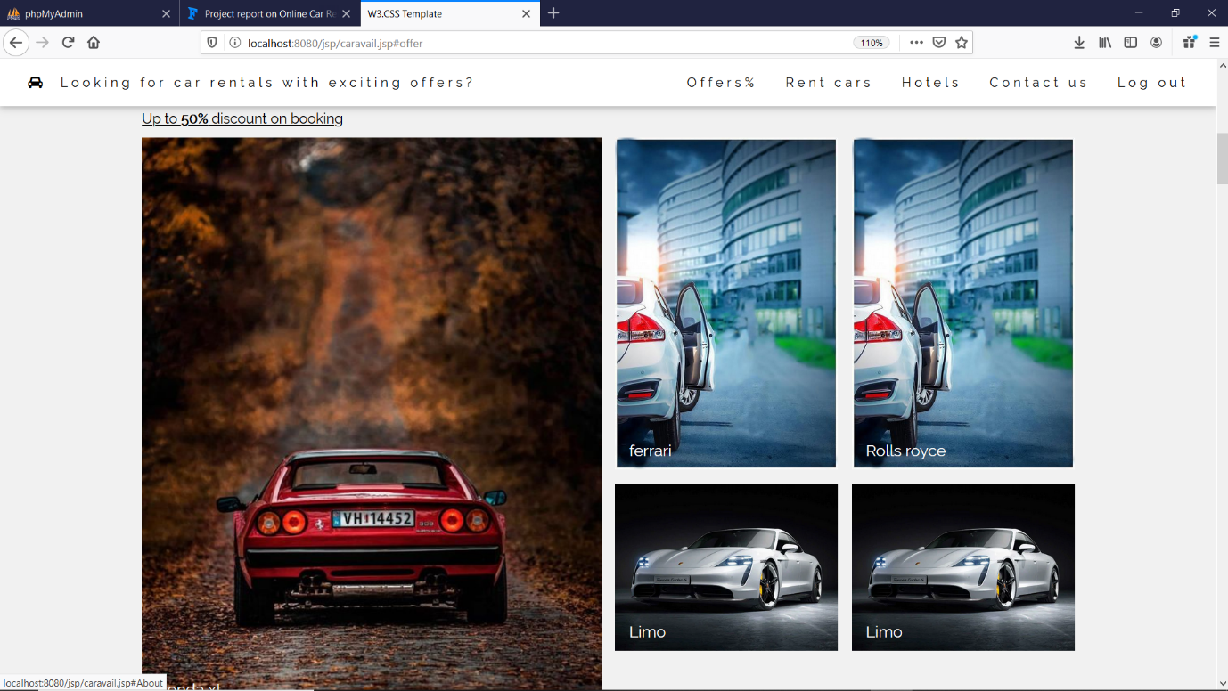

Car rental page

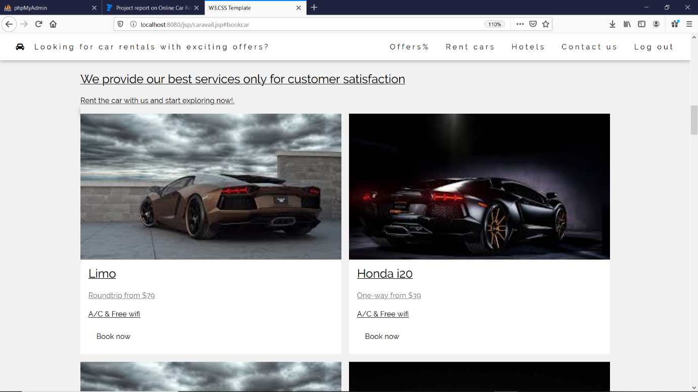

Car booking

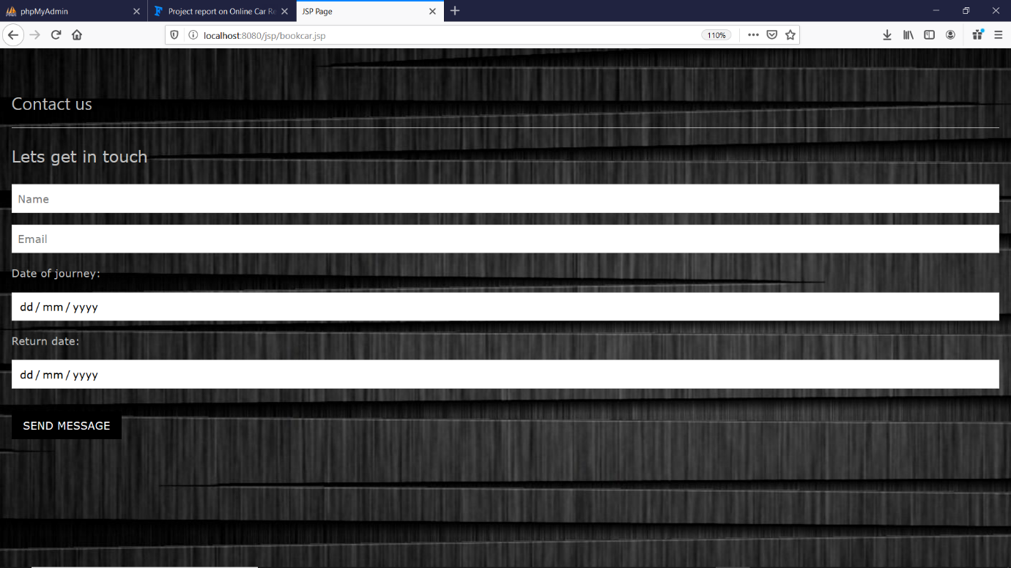

Hotel booking

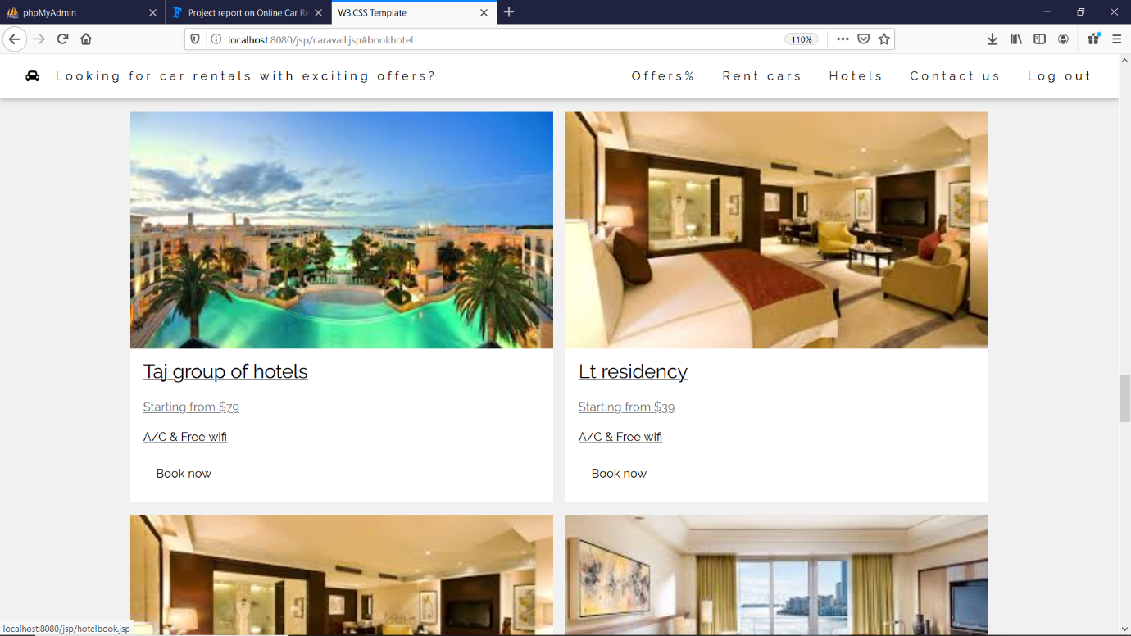

Contact desk page

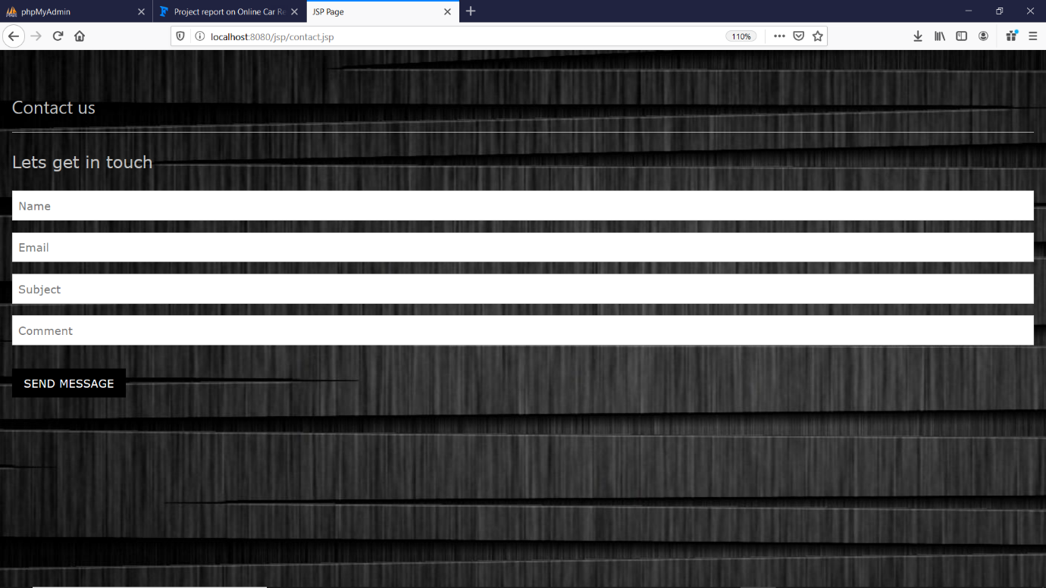

Confirm booking page

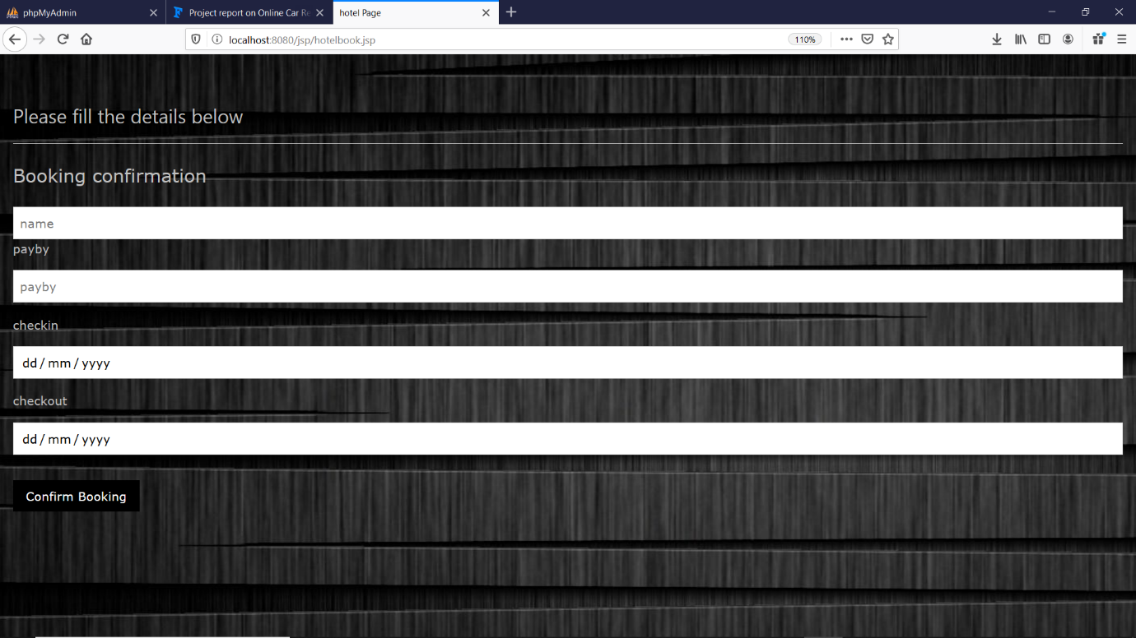

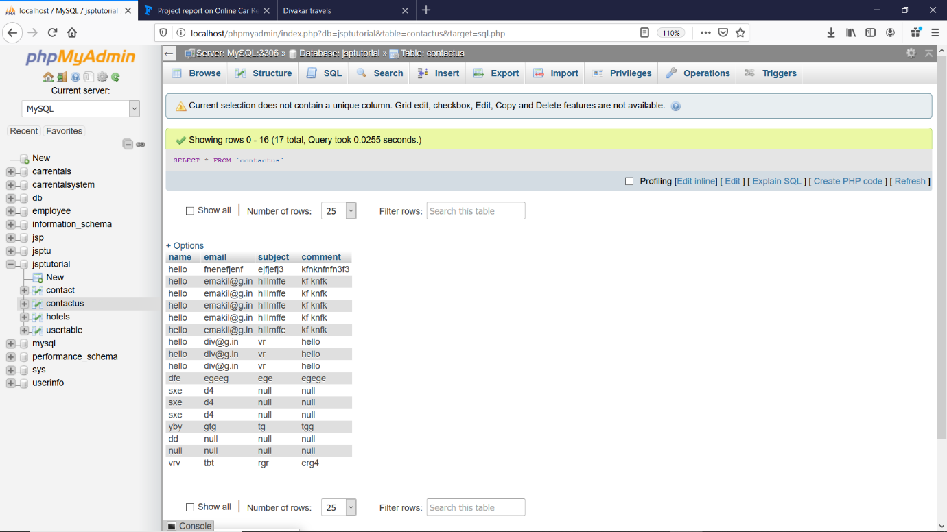

**6.RESULTS & DISCUSSION:**

* A web application is an application that is accessed over a network such as the Internet or an intranet. Therefore with this new method, the process will be more.
* Manual problems have been rectified and has came along way to prove the existence of the project.
* It also helps to avoid transaction lagging process and also it shows clearly that it overcomes the problems in the existing system.
* Also additionally the hotel rooms booking also incorporated in this project.So it makes the booking process easier for clients and also it serves as a business process.

**7) CONCLUSION;**

The web based car rental system has offered an advantage to both the customers as well as car rental company to efficiently and effectively manage the business and satisfies the customer needs. Car rental business has emerged with a new goodies compared to the past experience where every activity concerning the car rental is physical location only. This online car rental process makes the whole car rental booking process easier and convenient to use. Still the drawbacks of manual process can be completely overcome with the conversion of digital mode.